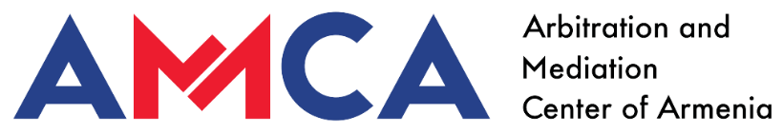

AMCA MODEL MEDIATION AGREEMENT
00․00․2025 Yerevan
THIS AGREEMENT IS MADE BETWEEN
Party 1 | Party 2
Name  Surname | Name  Surname
Address | Address
Email address | Email address
Tel. | Tel.

(together referred to as ‘the Parties’), AGREE about the following:

- The Parties agree to attempt in good faith to settle their dispute at the Arbitration and Mediation Center of Armenia (AMCA).
- The Dispute relates to [details about the dispute, object of the dispute].
- The Parties will be responsible for the costs and fees in accordance with AMCA Mediation Rules Appendix, current at the date of this Agreement. The parties are responsible for the costs equally, if not agreed otherwise.
- All written and verbal communication that takes place during the mediation process are confidential.

Signed
Party 1 Party 2
[name-surname] [name-surname]
[signature] [signature]
[date] [date]

