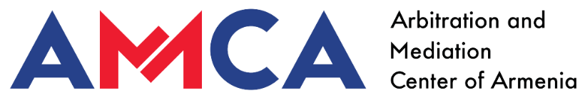

**Model Mediation clauses**

If any dispute arises in connection with this agreement, the parties will attempt to settle it by mediation in good faith in accordance with the Arbitration and Mediation Center of Armenia (AMCA) Mediation Rules.

Mediation is carried out by the mediator(s) appointed by the AMCA, who resolve the disputes in accordance with the Rules.The mediation case concerning the dispute shall be administered by AMCA.

The mediation will take place in [Yerevan, Armenia] and the language of the mediation will be [Armenian].