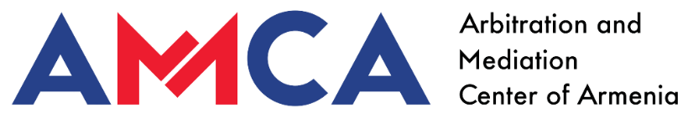

**Model Mediation-Arbitration clauses**

Any dispute, controversy or claim arising out of or relating to this  
contract, or the breach, termination, or invalidity thereof, shall be  
submitted to mediation in accordance with the AMCA Mediation Rules.

Mediation is carried out by the mediator(s) appointed by the AMCA, who resolve the disputes in accordance with the Rules. The mediation case concerning the dispute shall be administered by AMCA.

The mediation will take place in [Yerevan, Armenia] and the language of the mediation will be [Armenian].

If the dispute, or any part thereof, is not settled within [reasonable time]  
from the date of submission of the request to mediate under the AMCA Mediation Rules, the parties agree to resolve any remaining matters by arbitration in accordance with the  
AMCA Arbitration Rules.

The case is resolved by an arbitrator(s). The arbitrator is appointed by the AMCA. The arbitration case concerning the dispute shall be administered by AMCA.

The arbitration will take place in [Yerevan, Armenia] and the language of the arbitration will be [Armenian].